**Load Balancer**

**Step 1 – Create a Application Load balancer**

**Enter name, schema (internet facing), select VPC, AZ minimum 2, security group.**

**NoIt ask to create a target group- > create target group**

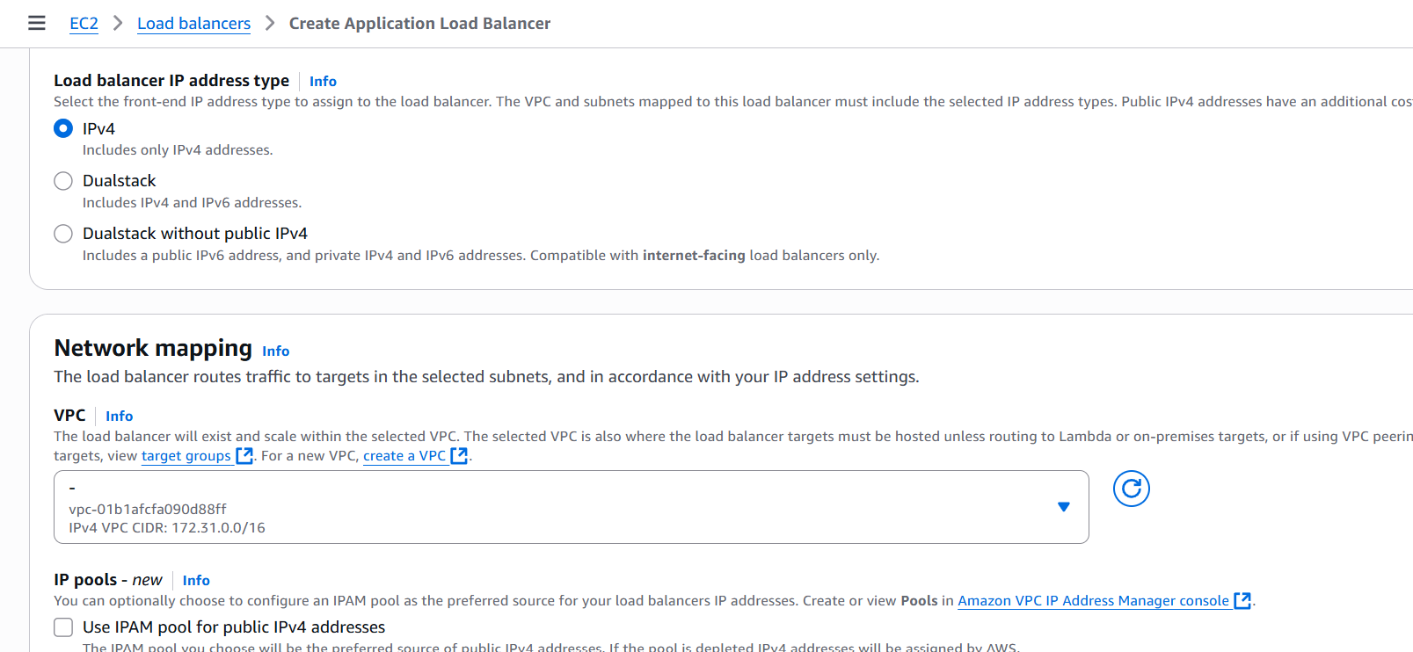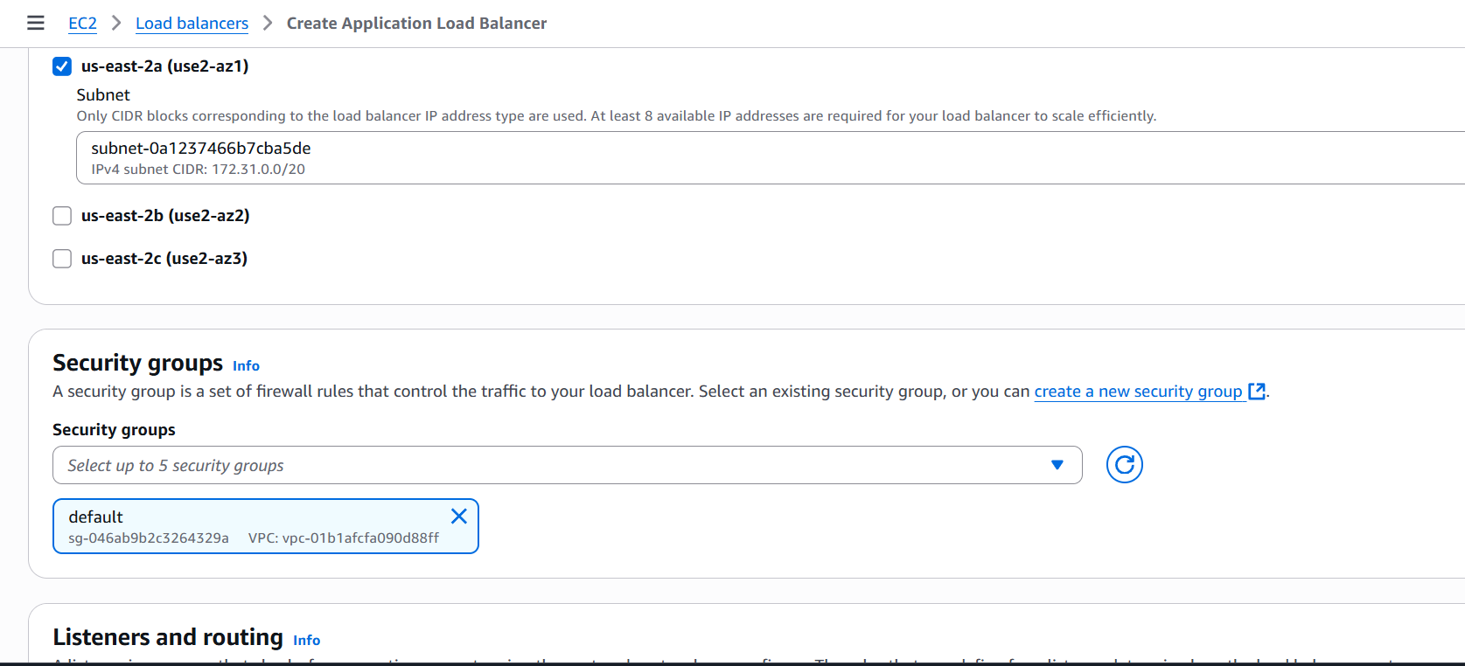

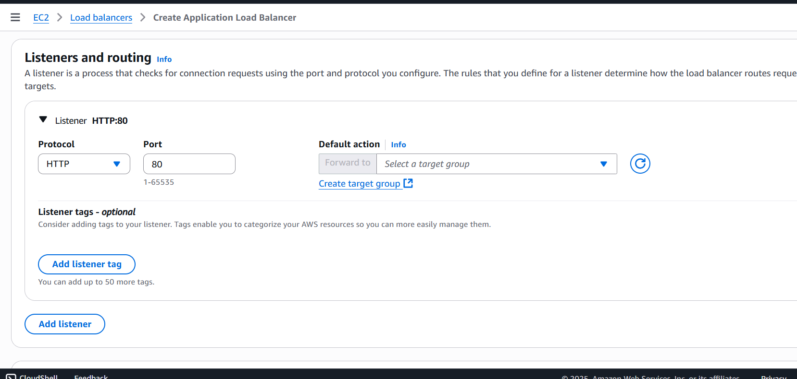

**Step 2 – select instances, target group name, click next**

**Now it ask for servers.**

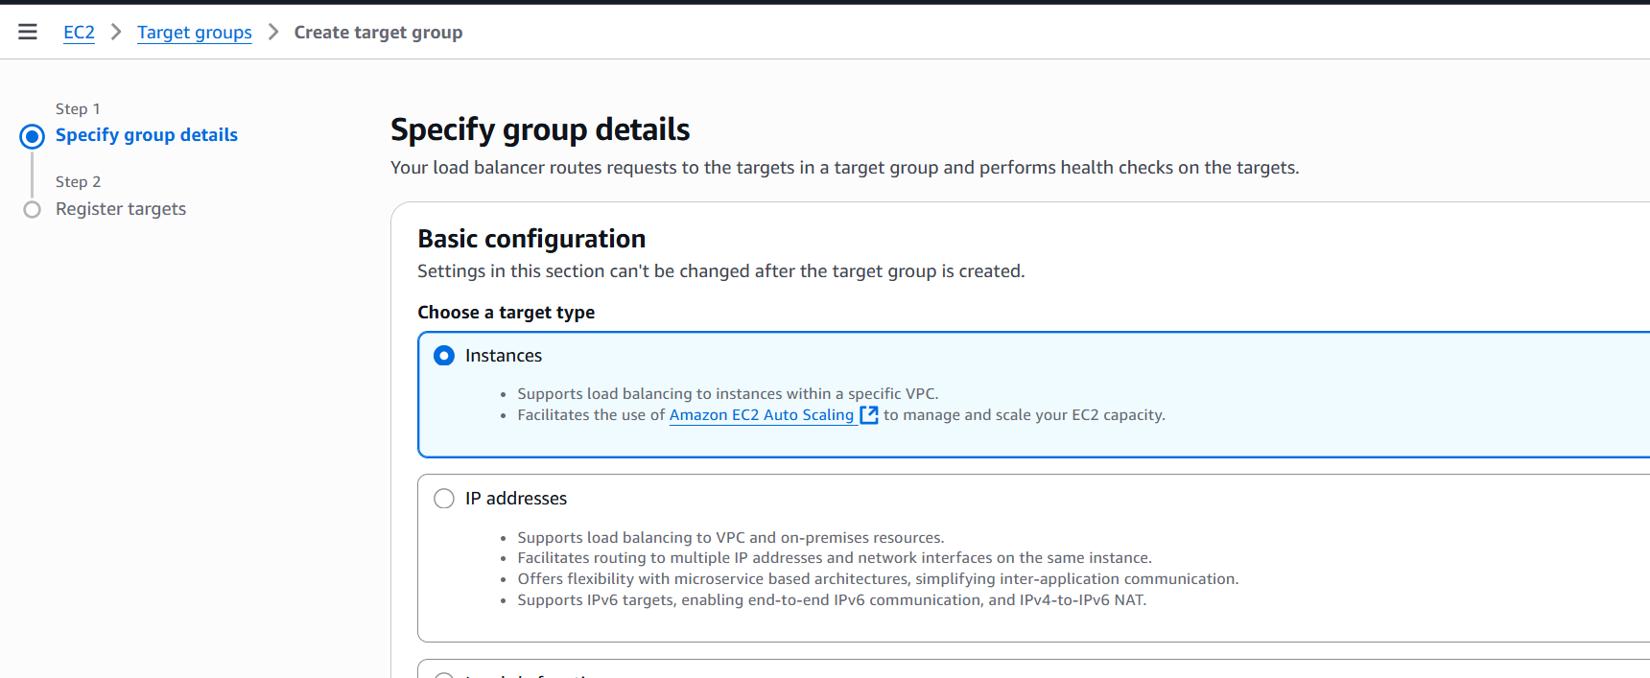

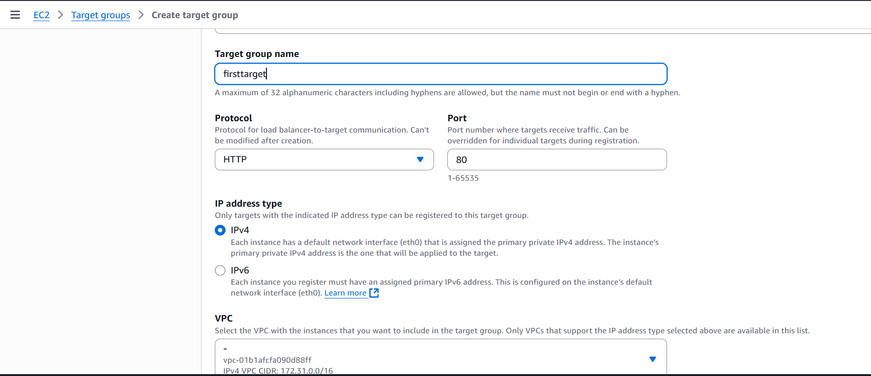

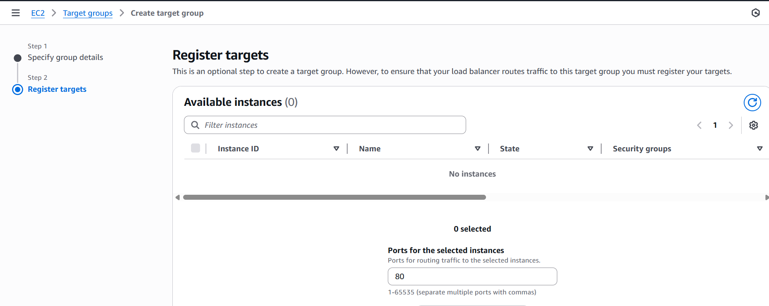

**Step 3 – Create a server, here I created 3 servers.**

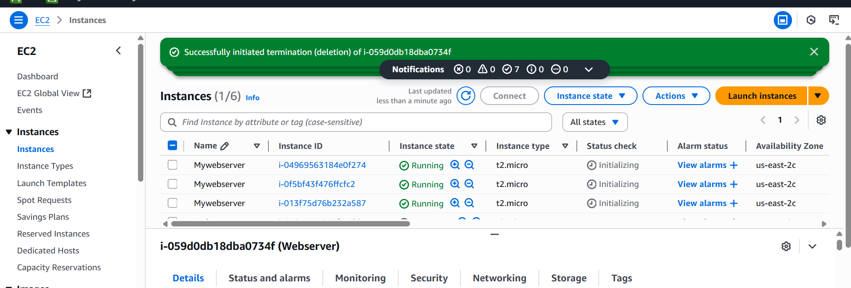

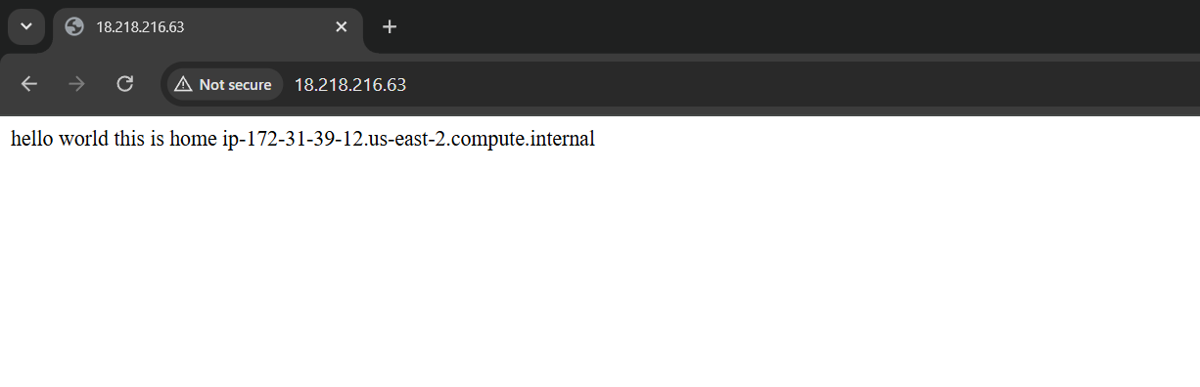

**Step 4 – Back to target group and select your server, click include as pending below, created.**

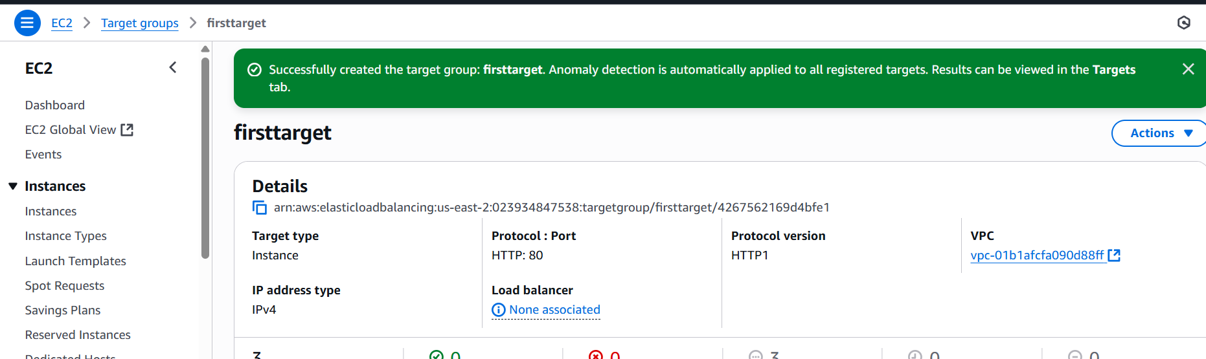

**Step 5- Back to Load balancer and select created target group. Click load balancer created.**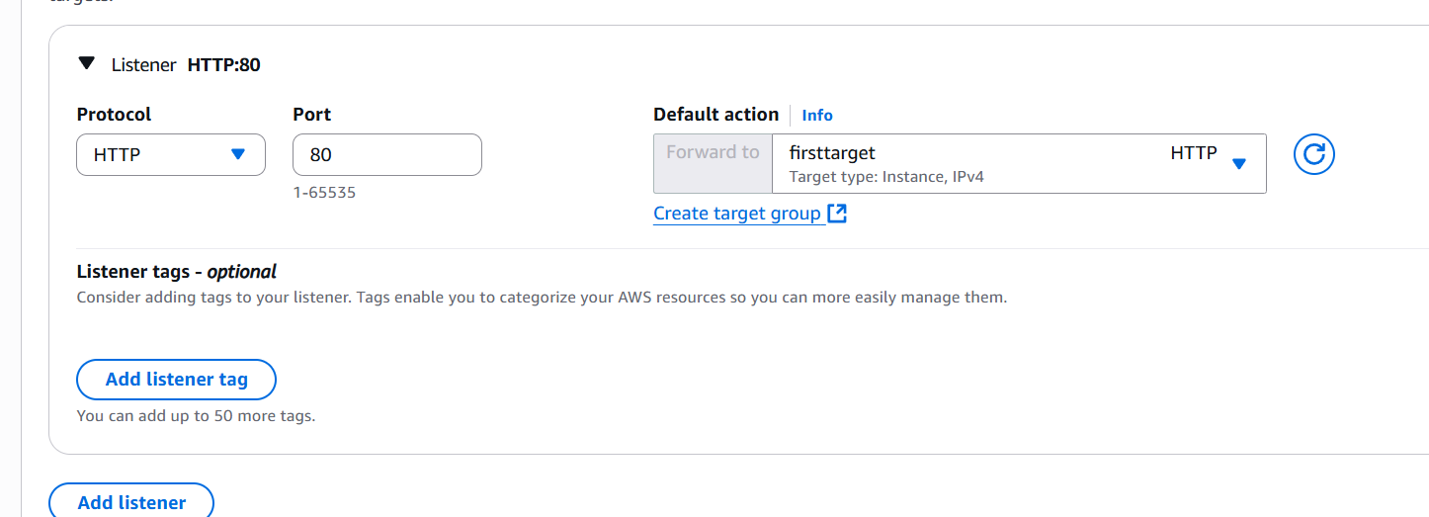

**Step 6 – Here Load balancer created successfully. Paste DNS name in browser & successfully able to connect.**

